SN Servicing Corporation
Services Provided
and Timelines

Company Introduction
SN Servicing Corporation (SNSC), was founded by Robin P Arkley, II, in 1987. Since 1987, SNSC has serviced more than $10 billion in assets and 280,000 loans for more than 175 clients and Mortgage Backed Securities.
SNSC excels at delivering flexible solutions for borrowers while maximizing returns for shareholders. For 20 years, SNSC primarily focused on acquiring, re-performing, Securitizing, and Servicing its own portfolio. Due to its success relative to its peers, SNSC was strongly encouraged to provide servicing for Investors during the economic downturn that began in 2007. Today, SNSC continues to provide full servicing for its clients while executing solutions as if they were part of its own Investment portfolio.
SNSC’s Mission is to execute on personalized and sustainable solutions for borrowers that consistently deliver fair, risk-adjusted returns for investors.
The Company is headquartered in Baton Rouge, Louisiana. Primary Servicing and Collections are located in Eureka, California with additional Collections performed in North Carolina and Louisiana.
Agency Standings:
- FHA - Approved Servicer since 1995
- VA - Approved Servicer since 1999
- USDA – Approved Servicer since 2007
- FNMA - Approved Servicer since June 2012
- North Carolina Housing Finance Agency – Approved Servicer in November 2012
- HAMP -
Servicing Operations - Overview
SN Servicing Corporation’s Servicing Operations are conducted from the Servicing Center located in Eureka, CA. Servicing functions include:
- Loan Boarding
- Loan Maintenance
- ARM Maintenance
- Cashiering
- Taxes
- Insurance
- Loan Records Management
- Collateral Management

DEFAULT ADMINISTRATION

Default Administration - Overview
SN Servicing Corporation’s Default Administration is conducted from the Service Center in Eureka, CA Default Administration functions include:
- Customer Service
- Collections
- Bankruptcy
- Foreclosure
- Loss Mitigation
- BPO Support
- REO
Portfolio Assignment
Loans are assigned to an Asset Manager at service transfer. The Company has instituted a special servicing, best practices, application where Asset Managers are responsible for applying collection strategies to accounts through all stages of the delinquency cycle.
- Establish a personal relationship with the borrower, which improves communication, increases accountability and enhances SNSC’s ability to dictate the performance or exit strategy of a loan;
- Allow for a seamless transition through the delinquency cycle with minimal interruption into asset workout & resolution process;
- Asset Manager’s average loan count varies depending upon loan characteristics (i.e. lien position, performance status, collateral type), investor requirements and Asset Manager’s experience;
- Client-specific team approach is available.

Proactive Early Intervention
An Asset Manager’s goal is to maintain the performing status of the loans or attain a re-performing status on delinquent loans to manage the loan to the best possible outcome.
- “Hello/Welcome Calls” are made 5-days post Service Transfer date, for the purpose of introducing themselves to the borrower, verifying account information, advising of the monthly billing statement, and providing the lockbox address for the borrower’s convenience.

- Asset Managers’ key responsibilities are:
- Frequent and early contact with delinquent borrowers (as early as 1 day delinquent) to determine willingness and ability to repay mortgage debt;
- Borrower’s current monthly budget and financial outlook;
- Proactive identification of short sales, modifications and Deed-in-Lieu opportunities in early stages of delinquency;
- Monitor market value of the property and determine liquidation time frame for “as is” versus repaired;
- Negotiate the best possible outcome in a bankruptcy filing;
- Review Quarterly Credit Scores;
- Aggressive and systematic Skip Tracing to support delinquency management via Web Based Services, internet options and data mining;
- Early Late Notices/Proactive Letters/Calling Campaigns;
- Concurrent collections ensures aggressive timeline management should asset disposition be required;
- Re-performance is actively pursued for each loan up until foreclosure sale.

Performing Loan – Collection Timeline

Delinquent/Re-Performing Loan – Timeline

Loss Mitigation Capabilities
SNSC’s Application Management System (AMS) is a custom built application “wrapper” that provides real time integrated access to enterprise data from ILS, SAP, Documentum, Data Warehouse as well as

custom solutions such as the Net Present Value, Foreclosure Management, REO Management, Payment Plans Management etc.
- The Net Present Value Model is a fully integrated loan level decision tool allowing for calculation for Foreclosure, Short Sale/Discounted Payoff, Deed-in-Lieu, Hybrid solutions as well as different modification programs; from HAMP-Like programs to client specific modification programs;
- The Asset Manager can instantly view changes to the resolution priorities as borrower’s financials or collateral conditions change;
- SNSC’s Net Present Value Model is highly customizable to address each investor portfolio strategies;
- The Asset Manager’s experience and knowledge of the borrower and collateral will ultimately dictate the best and most likely solution;
- All workout recommendations are subject to the approval of a Supervisor or the Department Manager.

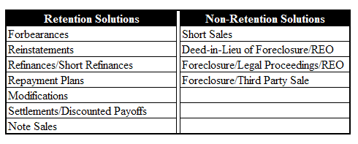
Modifications
The Company has a comprehensive modification program in place for borrower’s whose ability to pay is contingent upon reasonable term changes. Fully integrated DTI calculations, Net Present Value results and amortization schedules are utilized by the Asset Manager to determine the appropriate work-out.
- Modifications can be tailored to meet investor specific requirements;
- Solicitations are sent to borrowers who meet eligibility criteria;
- Underwriting review is performed to validate financial information and borrower situation;
- Exterior/Interior BPO to validate property market value;
- Fully integrated DTI calculations, NPV results and amortization schedules;
- Proactively manage the borrower through the trial plan and/or modification.

Short Sales/Refinances/Short Refinances/Deed-in- Lieu
Identify population that may be eligible for loss mitigation options.
- Review population with investor;
- Work with borrower, listing broker, lender and investor throughout the process;
- Continue with efforts to re-cash flow the asset;
- Recommend Real Estate Broker from SNSC’s list of preferred brokers if borrower requests assistance;
- Review property valuations and borrower’s financials;
- Negotiate with junior lien holder to obtain approval of the short sale;
- Offer Cash for Keys/Relocation incentive as directed by investor;
- Offer incentive to Listing Broker to promote timely closing of short sale;
- Always closely review HUD1 and monitor closing process.

Foreclosure
The Foreclosure Team coordinates and monitors foreclosure proceedings with outside counsel.
- The Asset Manager continues to be responsible for the overall management of the asset, while the Foreclosure Team handles the legal process;
- Loss mitigation strategies run parallel during the foreclosure process with the Asset Manager continuing to pursue alternative resolutions with the borrower;
- SNSC’s Foreclosure Management Module is an integrated workflow solution to track and manage the foreclosure process at every critical milestone;
- All Foreclosure proceedings are subject to evaluation and approval by the Foreclosure Committee. The committee includes: Internal Counsel, Chief Operations Officer, SVP of Default Administration, SVP of Loan Administration and Foreclosure Manager;
- SNSC works with a time-tested proprietary list of approved attorneys for each state;
- Each attorney is evaluated and ranked in the Vendor Management Scorecard in AMS.

Bankruptcy
The Bankruptcy Team receives or retrieves information relevant to the filings and monitors the bankruptcy proceedings from filing to dismissal/discharge.
- The loan is transferred to a BK Asset Manager for the duration of the Bankruptcy;
- Filing Number and Chapter are updated in the BK module in AMS;
- Complete and file a Proof of Claim;
- Monitor receipt of payments under bankruptcy plan;
- Determine if borrowers intends to keep property;
- Review and respond to proposed repayment plan under Chapter 11, 12, or 13;
- Move for a stay or order if borrower default (Lift of Stay requested within 90 days);
- Update Vendor Management scorecard in AMS, for evaluation and ranking of each attorney.

REO Management
Asset Managers are responsible for managing the marketing and the timely closing of REO Properties. REO Management initiatives to reduce days on market and improve net proceeds include:
- Pricing Strategy - Accurate assessment of property value with frequent review of pricing strategy and marketing presence; complete repairs as needed for best execution; negotiate highest “net proceeds” offer and close transaction;
- Single-Point-of-Contact - Broker had direct line to the Asset Manager; assistance with property premarketing (i.e. Eviction/Trash-out/Maintenance/Winterization); assistance with property premarketing (i.e. Eviction/Trash-out/Maintenance/Winterization);
- Timeline Management - Incent Real Estate Agents to close within pre-determined timeline; offer Cash for Keys for ‘occupied ’properties’; ensure Net Proceeds are received timely and closing documents are accurate and complete.

Property Valuations and Property Preservation
- The Company maintains a database of approximately 3,500 approved real estate Brokers located throughout the United States, a result of tested relationships over the years. These selected Brokers provide Broker Price Opinions (BPO), Competitive Market Analysis (CMA), and Property Conditions Reports;
- Valuations are reviewed for quality and accuracy to ensure assets reflect market value. Brokers are consistently evaluated based on accuracy and timeliness of their work. SNSC scores each broker based on these criteria to consistently ensure the Company is utilizing the most qualified and responsive Broker in each respective geographic area;
- The Company developed an integrated a solution in AMS for ordering, retrieving and processing valuations;
- SNSC’s valuations assume interior neglect, potential repair expense, and other REO related expenses. This approach enables SNSC to gauge potential marketing conditions;
- The Company has engaged Nationwide Management Services, Inc. to provide Property Inspections and Property Preservation Services in accordance with GSE’s requirements. To improve efficiencies we are currently working with Nationwide Management Services, Inc. to integrate data exchange;
- The Company is working with several well-known Valuation providers to handle BPOs and Appraisals in accordance with GSE’s requirements

Investor Reporting
Each month, Investors will be sent an Invoice along with a multi-tab spreadsheet that includes the following tabs of information for supporting details:
- Investor Summaries
- Loan Summaries
- Transaction Details
- Corporate Advance Details
- Ancillary Fee Details
- Servicing Fee Details
- Month-end Loan Snapshot
- Unapplied Transaction Details
- Escrow Transaction Details
SN Servicing also provides a robust Investor Reporting web site that provides 24x7x365 real time access to portfolio and loan details. There are 5 main sections:
- Charts – Shows I high level graphical summary of the Investor’s portfolio.
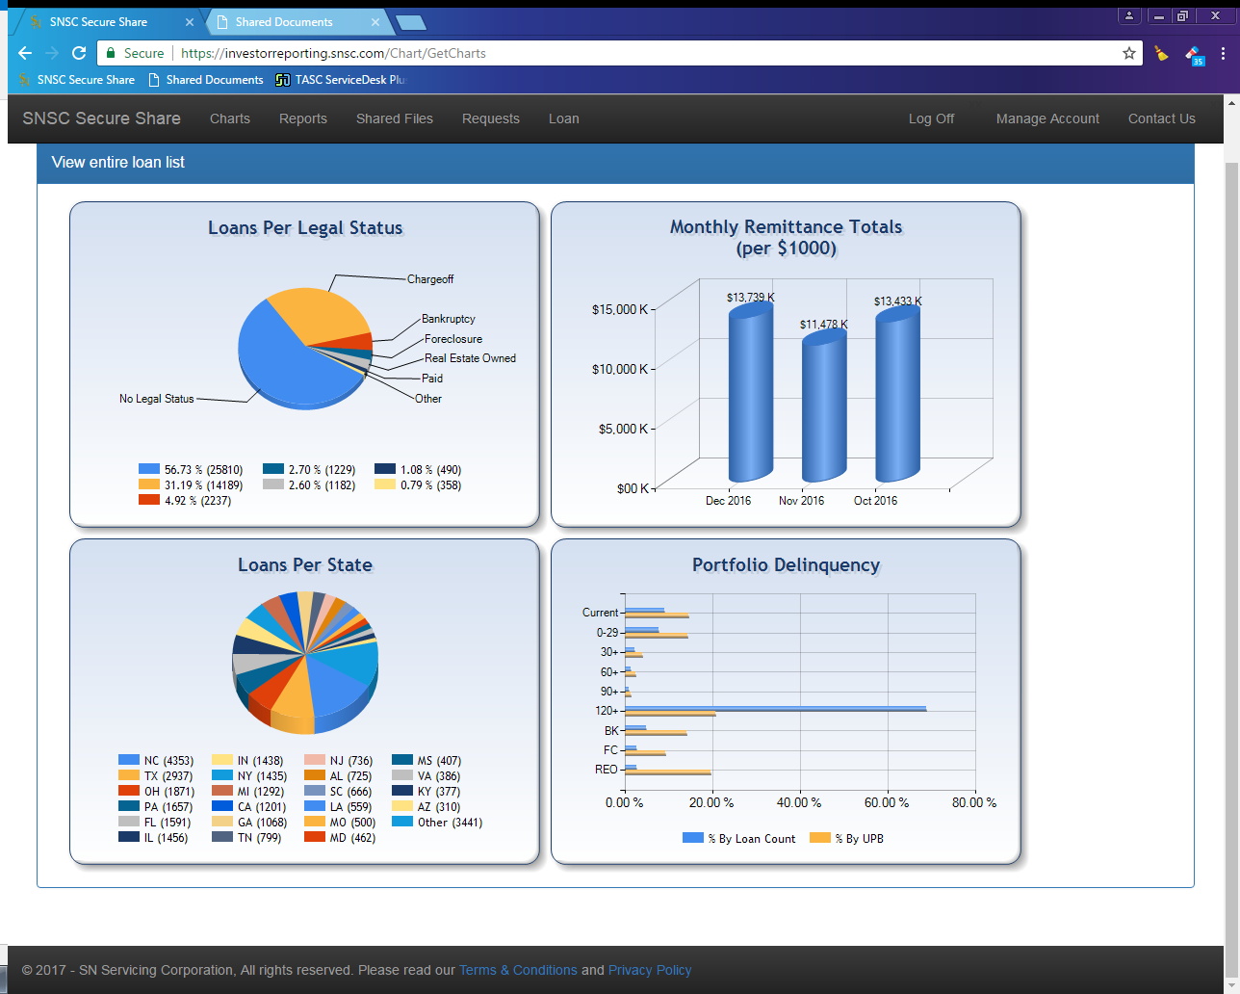
- Reports – Provides 40 expansive portfolio reports for all aspects of the loans, containing thousands of data points.
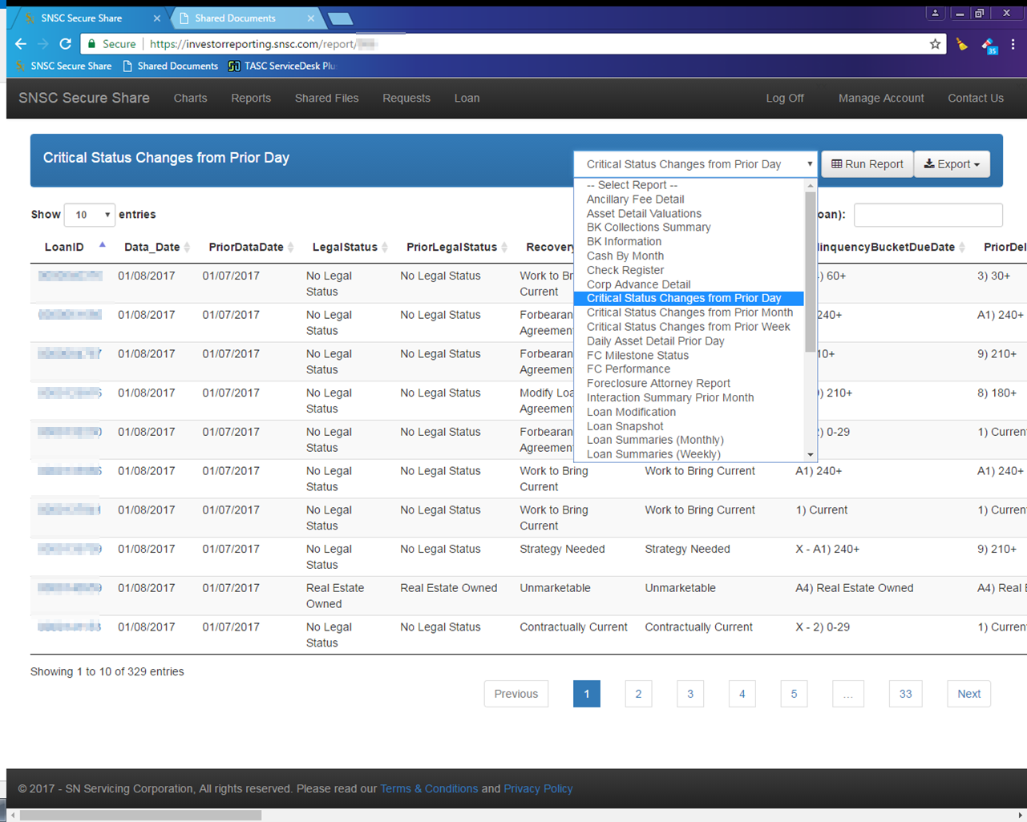
- Shared Files – Utility that allows safe transmission of private information between the Investor and Servicer.
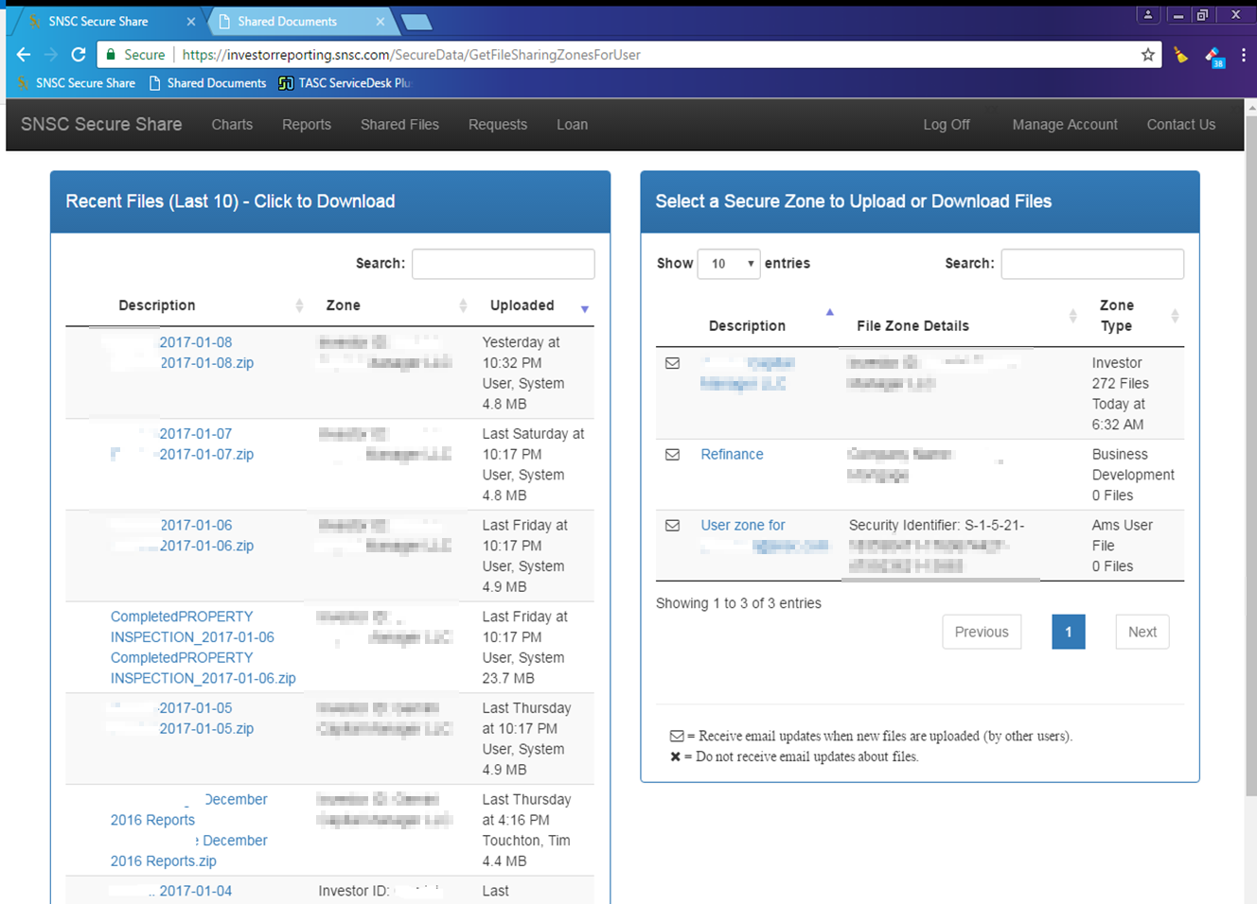
- Requests – Secure request ticketing system that keeps track of the status of any request made to SN. Allows the secure transfer of supporting documents and integrates within the Account Officer’s daily “To Do List”.
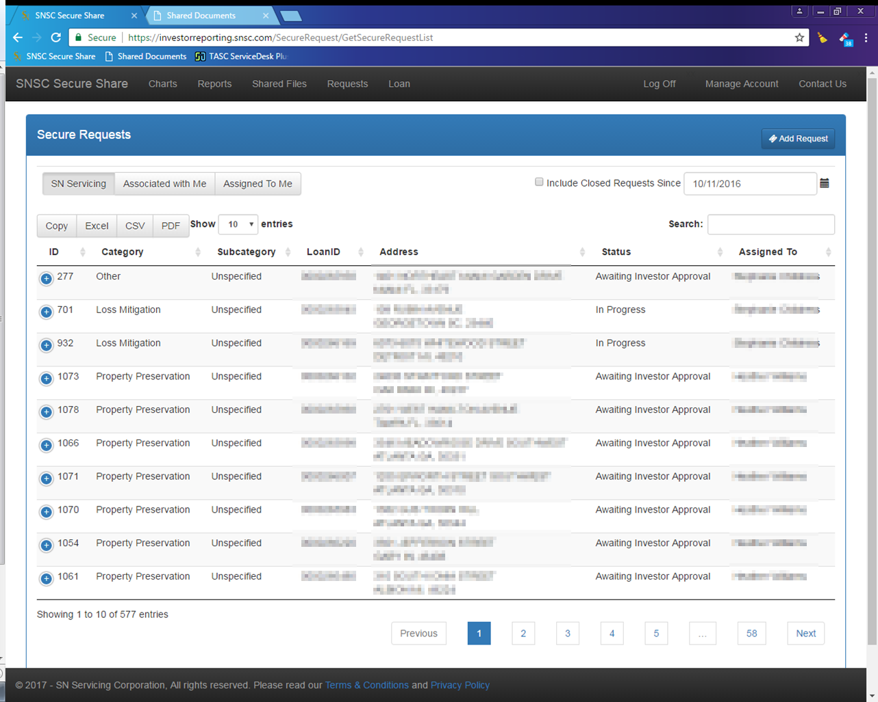
- Loan – Provides real-time detailed loan information, comments, transaction details, contact information, imaged documents, internal “To Do List”, Unofficial Payoff Quote, and Detailed Workflow timelines for Foreclosures and Loss Mitigation efforts.
